NACO 1097

Installation and Deployment Guide

Software Version: 2.4.6

August 7, 2023

Digital Bharat Collaborative

INSTALLATION AND DEPLOYMENT PROCEDURE DOC

Purpose:

This section is provided to give information on this version of the document.

The purpose of this document is to provide the System Administrator or any other technical stakeholder with a complete and easy to customize template designed specifically for the Technical Domain. It is intended to provide installation instructions to any stakeholder that has an interest or a role in the project.

**Document Responsibilities**

The is first created in the Deployment process step. Responsibilities for document creation and content are shown in the RACI[1] chart below:

|  |  |  |  |  |  |
| --- | --- | --- | --- | --- | --- |
| Intekhab A **HOD** | Shashank K  **Project Manager** | Saleem Syed **,**  Vijay Kumar N  **Technical Lead** | Avinsah  **Business Analyst** | **Atul, Wipro Team**  **Developer** | Manisha D S, Sachin  **Testing Analyst** |
| **I** | **A** | **R** | **I** | **C** | **I** |

**Reviews**

The is to be reviewed by the Technical Lead, and the Test Lead. At a minimum the review should ensure that the is technically correct and can be used to install and deploy the software or system in the target environment, resulting in a working and usable system.

**Approvals/Signoffs**

The is usually a deliverable component of the software solution. It is reviewed and bugs may be logged against it. But it is not approved or signed off unless required by the client scope/contract.

Installation Guide guidelines

**Acknowledgements**

This document may refer to use of products in the Microsoft® Office suite, the Microsoft® Team Foundation Server® and Visual Studio®. (Microsoft®, Team Foundation Server® and Visual

Ownership and revision

This is owned and controlled by the project’s System Administrator. After a baseline of this document is published, the Technical Lead shall ensure that it is placed under change control.

Each change or revision made to this Installation Guide Document shall be summarized in “Revision history” section of this document.

**Project leads and stakeholders : Mr. Madhu Telugu Project Manager**



Contents ii

1 Introduction 1-3

1.1 Purpose 1-3

1.2 Revision history 1-3

1.3 Signoffs **Error! Bookmark not defined.**

1.4 Intended audience and reading suggestions 1-3

1.5 Technical project stakeholders 1-3

1.6 References 1-3

2 Server Configurations 2-3

2.1 DataBase Server 1 (Database) 2-3

2.1.1 Roles, Features, and Packages 2-3

2.1.2 Configuration 2-3

2.1.3 Configured Values 2-3

2.2 Applicaiotn Server 2 (Web Application) 2-3

2.2.1 Roles, Features, and Packages 2-3

2.2.2 Configured Values 2-3

3 Software Installation 3-3

3.1 Database Server 1 (DB Server) 3-3

3.1.1 Prerequisites 3-3

3.1.2 Installation Steps 3-3

3.1.3 Configured Values 3-3

3.2 Applicaiotn Server 2 (Web Application) 3-3

3.2.1 Prerequisites 3-3

3.2.2 Installation Steps 3-3

3.2.3 Configured Values 3-3

4 Testing the Installation 4-3

5 Troubleshooting 5-3

Definitions, acronyms and abbreviations

# Introduction

## Purpose

The purpose of this is to describe in technical terms the steps necessary to install the software and make it operational.

## Revision history

The Revision history table shows the date, changes, and authors who have worked on this document.

| Version/Change request number | Version date | Description of changes | Author |
| --- | --- | --- | --- |
| 1 | 05/22/2023 | First Draft | Saleem Syed |

## Intended audience and reading suggestions

This is intended to be used by technical stakeholders of the project who will be responsible for planning, performing, or maintaining the installation or deployment, such as the Systems Administrator, Chief Information Officer (CIO), Analysts, or Developers.

It is intended that stakeholders and software support personnel can read this document and coordinate their efforts in the installation/deployment of the application.

## Technical project stakeholders

This section provides a list of all known stakeholders with an interest in the project.

| Name | E-mail address | Phone | Role |
| --- | --- | --- | --- |
| Neeraj & Anil | mokirala.kumar@wipro.com |  | Lead Developer |
| Vijay Kumar | vijay.nuthalpati@piramalswasthya.org |  | Systems Administrator |

## References

| Reference No. | Document | Author(s) |
| --- | --- | --- |
| REF-1 | Download Wildfly 11.0 Final and Redis | Microsoft |
| REF-2 | [How to: Install MYSQL 5.7.19 (Setup)](http://msdn.microsoft.com/en-us/library/ms143219.aspx) | Microsoft |
| REF-3 | [Microsoft .NET Framework 4 (Standalone Installer)](http://www.microsoft.com/download/en/details.aspx?displaylang=en&id=17718) | Microsoft |

# DB Server Configurations

|  |  |  |  |  |  |  |  |  |  |
| --- | --- | --- | --- | --- | --- | --- | --- | --- | --- |
| **S.NO** | **SERVER Brand NAME** | **SERIAL NUMBER** | **MODEL NUMBER** | **RAM** | **PROCESSOR** | **TOTAL STORAGE** | **I P** | **OS edtion** | **Project-App** |
|  |  |  |  |  |  |  |  |  |  |
| 1 | Lenovo Think System SR550 | J9008VXR | 7X04CTO1WW | 64 GB | Intel xeon silver 4210 2.20 Ghz | 2X600 GB 4X2.4 TB SAS | 198.168.35.151 | Windows 2016 STD edition | Live APP & Mysql Db |

## Server 1 (Database)

Installation of this product is supported on the following operation systems and versions:

* Windows Server 2016 x64 STD
* Windows Server 2016 x64 DC
* MYSQL 5.7.19 Server

### Roles, Features, and Packages

**Packages**

The following software packages must be installed on the operating system prior to installation of the software:

* MYSQL 5.7.19 Server
  + Database Engine
  + Connectivity Components
  + Management Tools

### Configuration

MYSQL Server Configuration:

### Configured Values

Use the table below to make note of the values for your installation environment for future reference. (Note: recording of information throughout should be in keeping with your local policies for system documentation and password security).

| Information | Value |
| --- | --- |
| Server name | AMRIT-1097 |
| SQL instance name | NACO DB Primary |
| SQL Server Administrator account name | Root |
| SQL Server Administrator account password | Rxxx@xxx |

**App Server 2 (Web Application)**

|  |  |  |  |  |  |  |  |  |  |
| --- | --- | --- | --- | --- | --- | --- | --- | --- | --- |
| **S.NO** | **SERVER Brand NAME** | **SERIAL NUMBER** | **MODEL NUMBER** | **RAM** | **PROCESSOR** | **TOTAL STORAGE** | **I P** | **OS edtion** | **Project-App** |
| 1 | Lenovo Think System SR650 | J30A7PLP | 7X06CTO1WW | 64 GB | Intel xeon silver 4216 16C 2.10 Ghz | 2X600 GB 4X2.4 TB SAS | 192.168.35.140 | Windows 2016 DC edition | NACO GR Dev |
| 2 | Lenovo Think System SR550 | J9008VXR | 7X04CTO1WW | 64 GB | Intel xeon silver 4210 2.20 Ghz | 2X600 GB 4X2.4 TB SAS | 198.168.35.151 | Windows 2016 STD edition | Live APP |
| 3 | Lenovo Think System SR550 | J9008VXT | 7X04CTO1WW | 64 GB | Intel xeon silver 4210 2.20 Ghz | 2X600 GB 4X2.4 TB SAS | 198.168.35.152 | Windows 2016 STD edition | App-Bkp and DB replication |

Installation of this product is supported on the following operation systems and versions:

* Windows Server 2016 x64 STD
* Windows Server 2016 x64 DC

### Roles, Features, and Packages

**Roles**

The following server roles must be enabled on the operating system prior to installation of the software:

* Wildfly Final 11.0.0
* MSOpenTech Redis 3.0 x64
* JAVA 8.0.202 SE JDK x64

**Packages**

The following software packages must be installed on the operating system prior to installation of the software:

* Microsoft .NET Framework 4.0 Standalone Installer 2013 and 2015 x64

### Configured Values

Use the table below to make note of the values for your installation environment for future reference.

| Information | Value |
| --- | --- |
| Server Name |  |

# Software Installation

## DB Server 1 (Database)

### Prerequisites

1. All steps in section 2 “Server Configurations” have been performed.

### Installation Steps

#### mySQL 5.7: Installation Instructions (Windows)

1. Go on to [***mySQL***](https://dev.mysql.com/downloads/mysql/) website to download.

2. Click the **Download** button under **MySQL Installer 5.7 for Windows**.

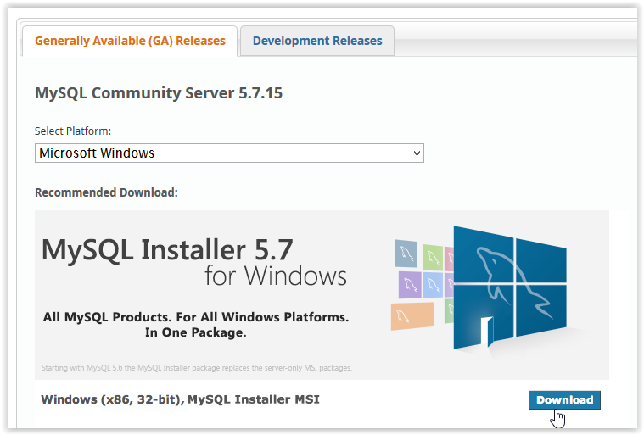

3. After clicking Download, choose which **Installer** to use by clicking**Download**.

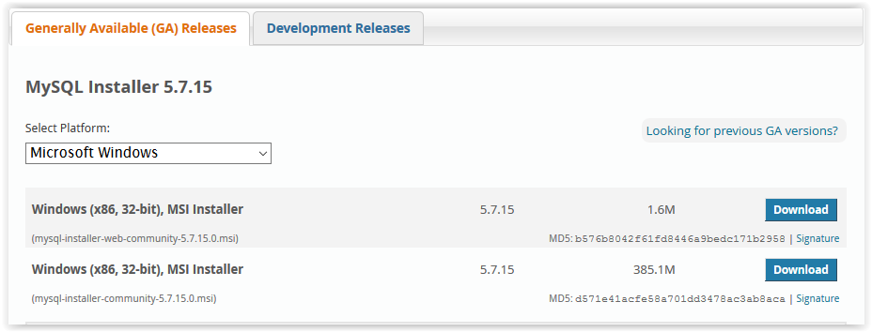

4. In order to download, you must click **Login**, **Sign Up**, or click **No thanks, just start my download**.

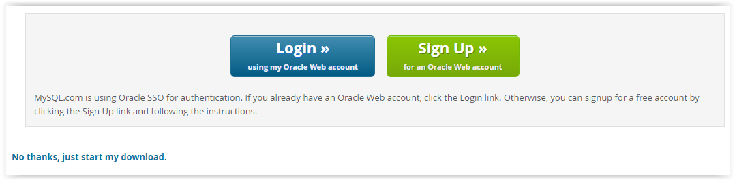

5. If prompted, select **Yes** to allow changes to the computer.

6. After downloading, check the **I accept** box under the License Agreement and click **Next**.

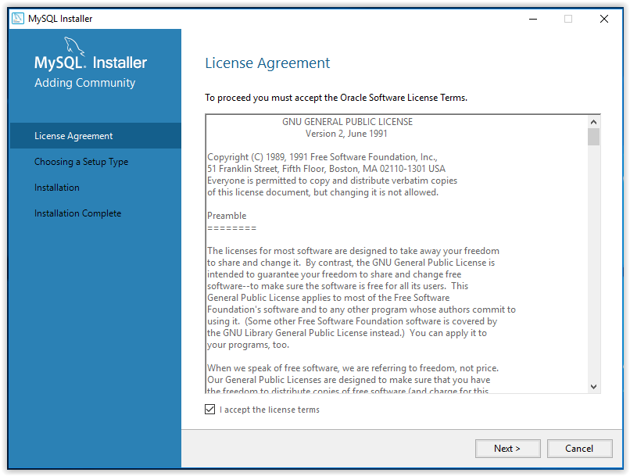

7. Select the **Setup Type** then click **Next**.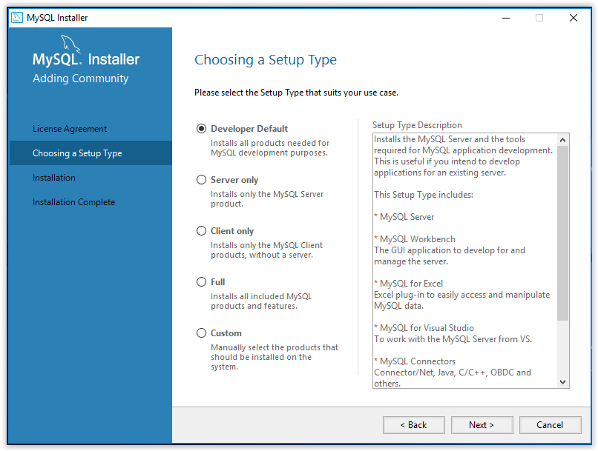

8. To begin the installation, press**Execute**.

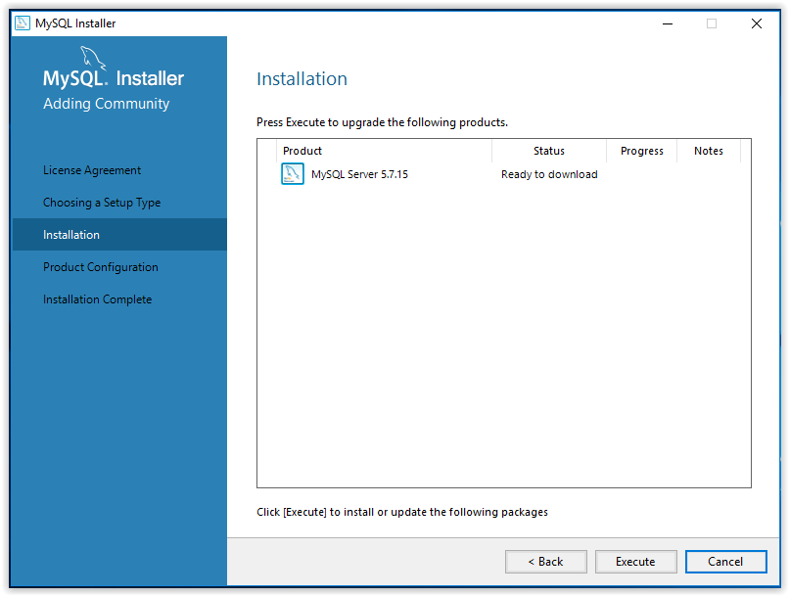

9. When the installation is complete, click **Next**.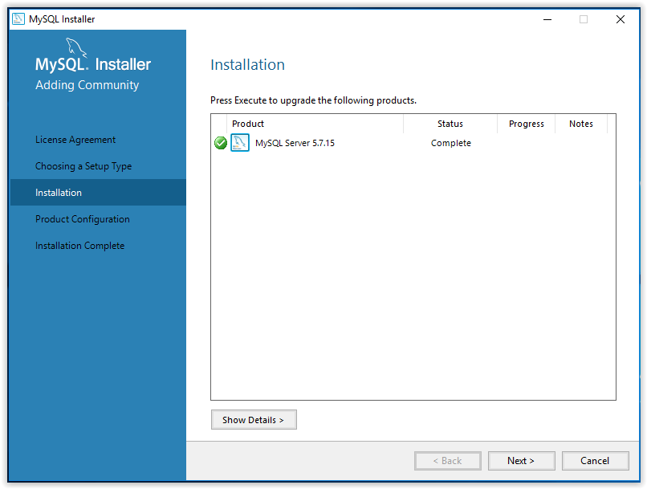

10. A walk-through product configuration will then appear. Click **Next** to begin.



11. First, select the Server Configuration Type then click **Next**.

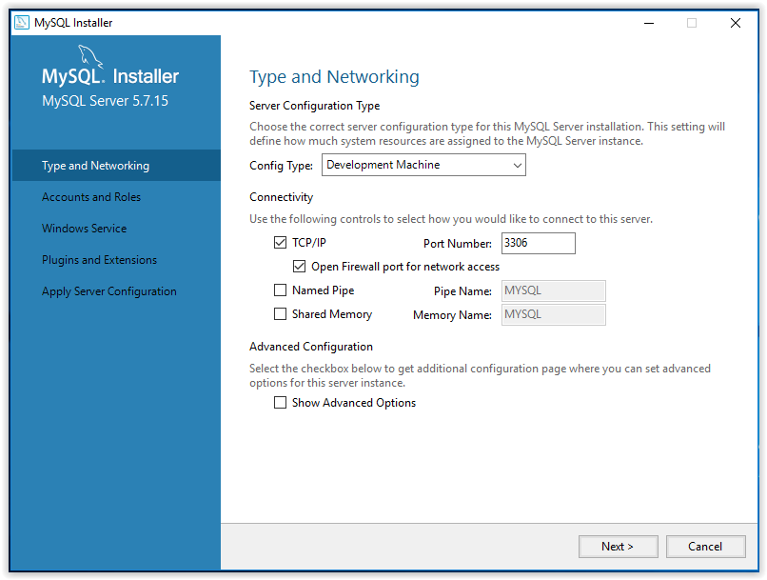

12. Set an account password, then click **Next**.

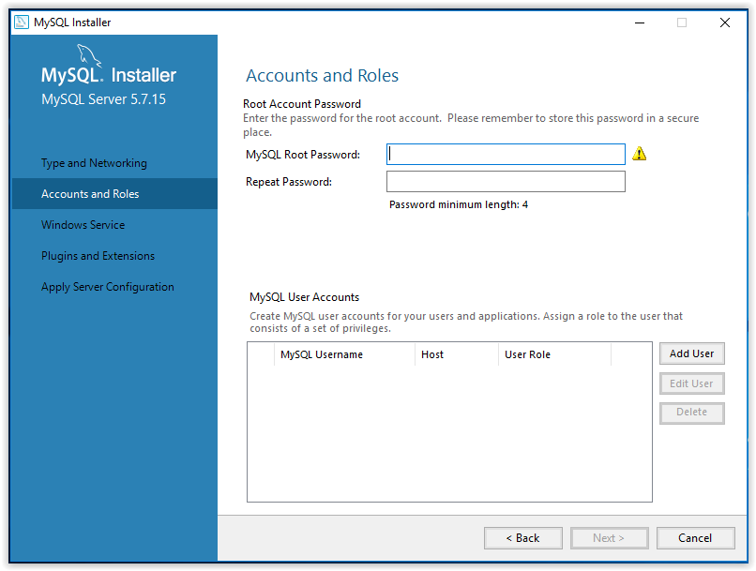

13. Choose a name for the installed program, choose a user account under which the program will be used, then click **Next**.

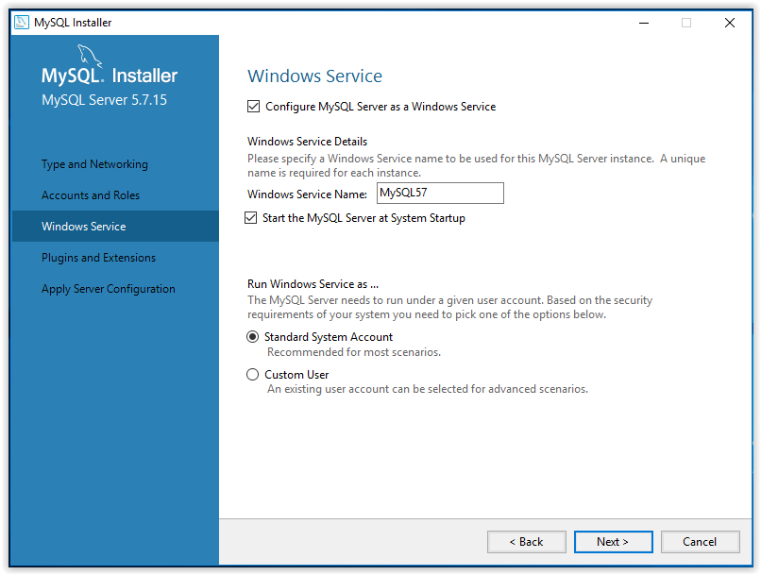

14. Use the Plugins and Extensions window to choose how the program will connect to the server, then click **Next**.

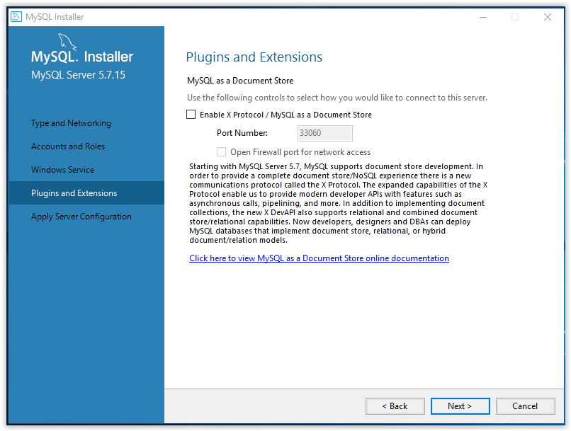

15. To apply the chosen settings, click **Execute** in the **Apply Server Configuration** window.

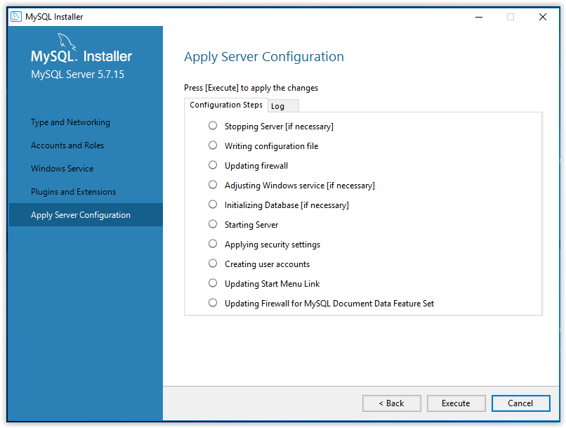

16. When the configuration is complete, click **Finish**.

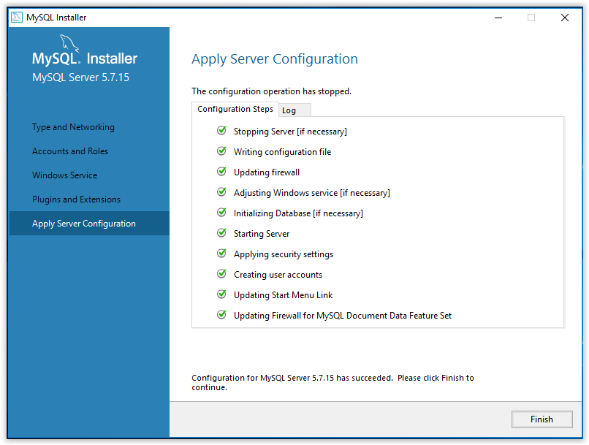

17. The program will then go back to the **Product Configuration** screen. Click **Next**.

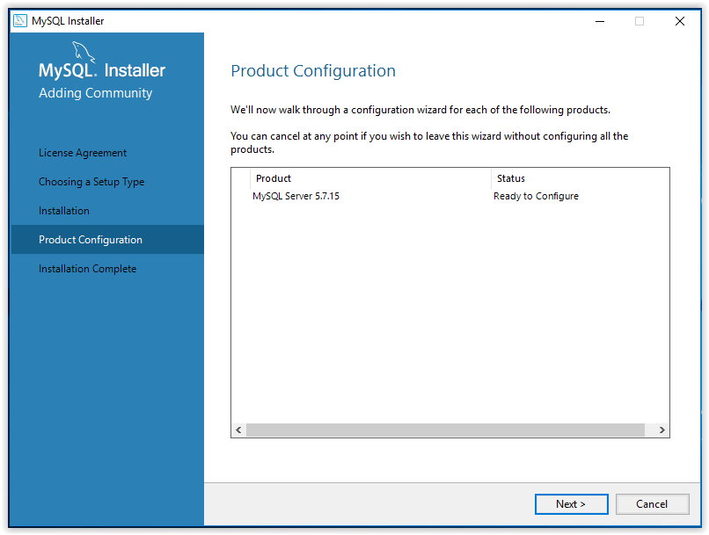

18. Installation is now complete. Click **Copy Log to Clipboard** to see the ReadMe file, or click **Finish**.

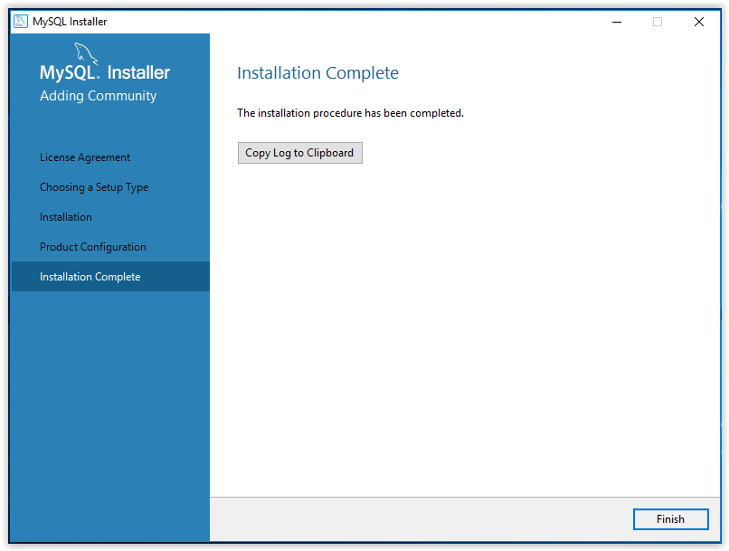

### Configured Values

Use the table below to make note of the values for your installation environment for future reference.

| Information | Value |
| --- | --- |
| Initial application administrator domain account name (domain\account) |  |
| dbo.aspnet_Users UserId |  |
| application_owner account password |  |
| applicationproviders_owner account password |  |

## APP Server 2 (Web Application)

### Prerequisites

1. All steps in section 2 “Server Configurations” have been performed.
2. All steps in section 3.1 “Software Installation, Server 1 (Database)” have been performed.

### Installation Steps

1. Contact your SharePoint administrator and note the following in section 3.2.3:
   1. SharePoint URL
   2. SharePoint dashboard access domain
   3. SharePoint dashboard access user name
   4. SharePoint dashboard access password
2. Contact your ArcGIS administrator and note the following in section 3.2.3:
   1. XYZ map layer service URL
   2. ABC map layer service URL
3. Log in as a server administrator.
4. Create a folder to house the web application files and note the location in the Physical path field in section 3.2.3.
5. Copy deployment files to the folder you created in step 2.

# How to install WildFly application server

26 January 2023 by [F.Marchioni](https://www.mastertheboss.com/author/admin/)

This tutorial covers **how to install** **WildFly application server**on Linux and Windows machines. First off, you need to download a JDK which is supported by WildFly. Then, we will download and unzip the application server.

**How to install WildFly application server**

26 January 2023 by [F.Marchioni](https://www.mastertheboss.com/author/admin/)

This tutorial covers **how to install** **WildFly application server**on Linux and Windows machines. First off, you need to download a JDK which is supported by WildFly. Then, we will download and unzip the application server.

## Installing Java

Firstly, if you are not sure which JDK to download, check this article: [Choosing the right JDK for WildFly and JBoss EAP 7](https://www.mastertheboss.com/jbossas/wildfly-8/choosing-the-jdk-for-wildfly-and-jboss-eap-7/) .

Next, Install the Production and Early-Access OpenJDK Builds for your OS from : <https://jdk.java.net/>

### Environment variables settings

Once you have installed Java, set the **JAVA_HOME** and include in your **PATH** the bin folder of your Java installation.

Windows Users:

1. Open the **Start** menu and search for *environment variables*.
2. Select the **Edit the system environment variables** result.
3. In the *System Properties* window, under the *Advanced*tab, click **Environment Variables…**
4. Select the Path environment variable and Edit to include the bin folder where java/javac is available:

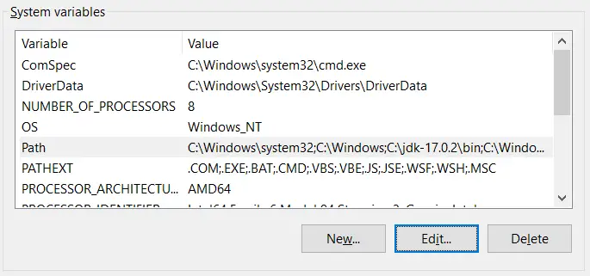

Finally, define a new environment variable JAVA_HOME which points to the root folder where you have installed Java:

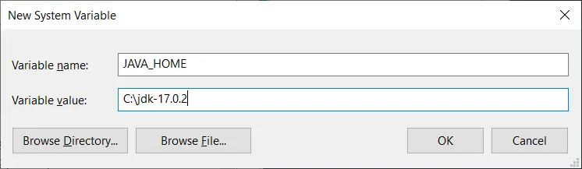

## Installing WildFly

Navigate to <https://wildfly.org/downloads/> and download the zip file with the latest stable version of WildFly application server. Unzip the archive and move to the “bin” folder.

Alternatively, you can also download it from the command line with any tool such as curl. For example to download WildFly 27:

curl -L -O https://github.com/wildfly/wildfly/releases/download/27.0.1.Final/wildfly-27.0.1.Final.zip

Move to the folder “bin” which is under WildFly installation and start WildFly with:

$ ./standalone.sh

Windows user will start the application server with:

standalone.bat

The application server will start as you can see from the Console:

15:47:25,343 INFO [org.wildfly.extension.undertow] (MSC service thread 1-4) WFLYUT0006: Undertow HTTPS listener https listening on 127.0.0.1:8443

15:47:25,432 INFO [org.jboss.ws.common.management] (MSC service thread 1-3) JBWS022052: Starting JBossWS 5.3.0.Final (Apache CXF 3.3.3)

15:47:25,551 INFO [org.jboss.as.server] (Controller Boot Thread) WFLYSRV0212: Resuming server

15:47:25,553 INFO [org.jboss.as] (Controller Boot Thread) WFLYSRV0060: Http management interface listening on http://127.0.0.1:9990/management

15:47:25,553 INFO [org.jboss.as] (Controller Boot Thread) WFLYSRV0051: Admin console listening on http://127.0.0.1:9990

15:47:25,553 INFO [org.jboss.as] (Controller Boot Thread) WFLYSRV0025: WildFly Full 18.0.0.Final (WildFly Core 10.0.0.Final) started **in** 3120ms - Started 315 of 577 services (369 services are lazy, passive or on-demand)

You can check that it’s running, by reaching the home page at localhost:8080

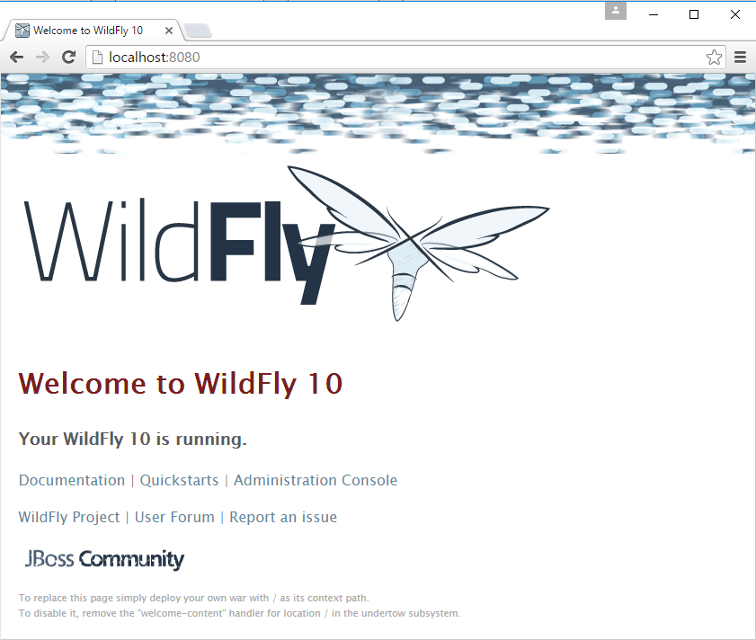

## Configuring WildFly as a service on Windows

Installing WildFly as a service for Linux machines is discussed in this tutorial: [How to run WildFly as Service](https://www.mastertheboss.com/jbossas/jboss-configuration/run-jboss-as-service-howto/)

In order to install WildFly as service on Windows, you will need the following steps:

* Firstly, move to the folder “JBOSS_HOME\docs\contrib\scripts\”.
* Next, copy the **service** directory to JBOSS_HOME\bin
* Then, open an Admin Shell and navigate into the **service** folder
* Finally, run “**service.bat install**“

Next open windows Services, you should see Wildfly installed, you can now start it from here and set it to automatic:

### Configured Values

Use the table below to make note of the values for your installation environment for future reference.

| Information | Value |
| --- | --- |
| Physical path | E:/Appserver/wildfly-final-11.0.0/standalone |
| IP Address (if static) | 192.168.35.152 |
| Host name | NACO-APP-Server1 |
| App CRM login URL | 192.168.35.152:8080/#/login |
|  |  |

# Testing the Installation

1. Navigate your web browser to the Host Name you noted in section 3.2.3.
2. Ensure that the login prompt appears.

# Troubleshooting

This section is optional. Here you can describe troubleshooting steps including log locations and other information that may assist an administrator and the development team in determining the root cause and resolution to any issues that arise.

## Definitions, acronyms and abbreviations

| Term | Definition |
| --- | --- |
| Administrator | This is anyone from the client that has been given administrative rights in the NACO 1097. |
| MYSQL | MY Structured Query Language |

1. RACI stands for: R – Responsible - "Saleem Syed"; A – Accountable - "Shashank K" ; C – Consulted - "Wipro dev team ; I – Informed - "Intekhab A"